
Project 3
Comparison of Deep Learning Architectures

A Study of Feedforward Neural Networks, Convolutional Neural Networks, and Recurrent Neural Networks
Course: Deep Learning
Name: Keerthi N
Reg No: 2411021240024
Date: 31/07/2026

Department of Computer Application
Alliance University
Chandapura - Anekal Main Road, Anekal
Bengaluru – 562106
1.INTRODUCTION

When I started reading about deep learning, the first thing that confused me was how many different kinds of neural networks exist and why we can't just use one type of network for every problem. After going through the theory and a few example implementations for this project, it became clear that the choice of architecture depends heavily on the kind of data we are working with and what we are trying to predict. This report is my attempt to study and compare three of the most fundamental deep learning architectures - Feedforward Neural Networks (FNN), Convolutional Neural Networks (CNN), and Recurrent Neural Networks (RNN) - and understand where each one fits best.
The report is organised in three parts, following the tasks given in the project. Task 1 looks at the basic structure of each architecture. Task 2 identifies the kind of real-world problems each network is good at solving. Task 3 puts all three side by side and compares them directly on structure, the type of input data they expect, and their typical applications. Simple black and white diagrams are included throughout to make the architectural differences easier to visualise, since I found that just reading definitions without a picture made it harder to remember how the layers actually connect.

2. Task 1: Basic Architecture of Each Network
2.1 Feedforward Neural Network (FNN)
A Feedforward Neural Network is the most basic type of artificial neural network, and it is usually the first one taught in any deep learning course. The name itself describes how it works: information flows in only one direction, starting from the input layer, passing through one or more hidden layers, and finally reaching the output layer. There are no loops and no memory of previous inputs - every prediction is made independently of the ones before it.
Each neuron in a layer is connected to every neuron in the next layer through what is called a fully connected (or dense) connection. Every connection has a weight attached to it, and every neuron applies an activation function (such as ReLU or Sigmoid) to decide how strongly it should fire. During training, the network compares its output to the actual answer and adjusts the weights backward through the layers using backpropagation, gradually reducing the error.
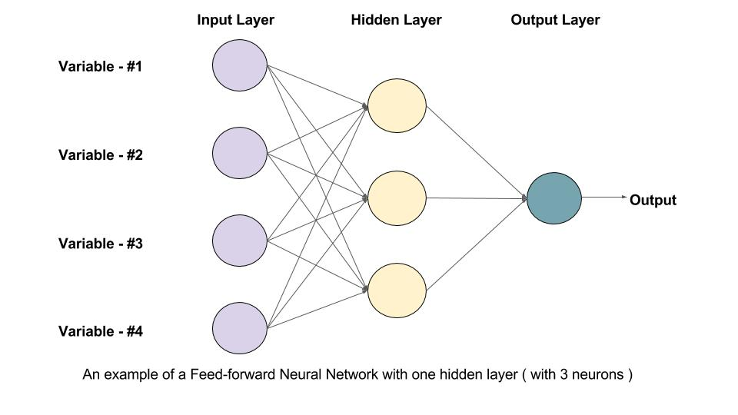
A simplified FNN has one input layer, one or two hidden layers, and an output layer, with every node connected to every node in the next layer - this is exactly what makes the network 'fully connected'. Because of this dense connectivity, feedforward networks can become very heavy in terms of parameters when the input is large, which is one of their biggest limitations.
Example: Suppose a bank wants to predict whether a customer will repay a loan. The input features could be income, age, credit score, and existing debt - four fixed numbers. An FNN takes these four values as input neurons, passes them through a couple of hidden layers, and outputs a single probability (repay / default). Since there is no spatial or sequential relationship between income and age, a plain feedforward network is a perfectly natural fit here.

2.2 Convolutional Neural Network (CNN)
CNNs were designed specifically to deal with the problem that feedforward networks struggle with grid-like data such as images. Instead of connecting every pixel to every neuron (which would need an enormous number of parameters), a CNN uses small filters (also called kernels) that slide across the image and learn to detect local patterns such as edges, corners, and textures.
A typical CNN has three main types of layers working together. The convolution layer applies filters over the input to produce feature maps that highlight important patterns. The pooling layer (usually max pooling) then reduces the size of these feature maps, keeping the most important information while making the network faster and less prone to overfitting. After a few rounds of convolution and pooling, the resulting feature maps are flattened into a single vector and passed through one or more fully connected layers, which behave exactly like the FNN described above, to make the final prediction.
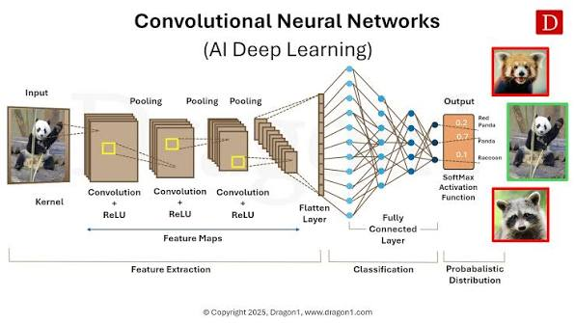
In this pipeline, an input image goes through convolution and pooling stages that shrink the spatial size while extracting features, and the flattened output is finally classified by a small fully connected network. What stood out to me while studying this is that the same filter is reused across the entire image (this is called parameter sharing), which is exactly why CNNs need far fewer parameters than a fully connected network would for the same image size.
Example: Consider an app that identifies whether a photo contains a cat or a dog. The image is fed in as a grid of pixels. Early convolution layers pick up simple edges and textures, deeper layers combine these into shapes like ears or a snout, and by the time the data reaches the fully connected layers, the network has enough high-level features to confidently output 'cat' or 'dog'.
2.3 Recurrent Neural Network (RNN)
RNNs solve a completely different problem - they are built for sequential data, where the order of the input matters and where earlier inputs should influence how later ones are interpreted. Examples include text, speech, and time-series data such as stock prices.
The key idea behind an RNN is the hidden state, which acts like a short-term memory. At every time step, the network takes the current input together with the hidden state from the previous time step, and produces both an output and an updated hidden state that gets passed forward to the next step. This is why RNNs are usually drawn in two ways - a compact form with a loop pointing back into the same cell, and an 'unrolled' form that shows the same cell repeated across each time step, all sharing the same weights.
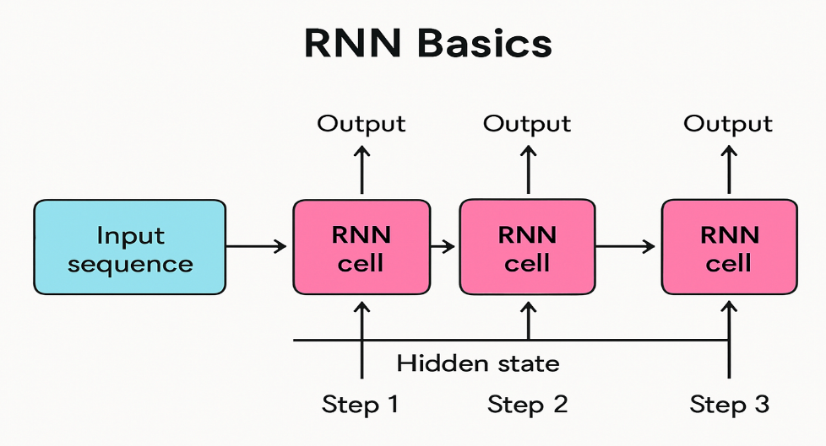
RNNs are usually shown in two ways: a compact form with a self-loop representing the recurrence, and an 'unrolled' form that shows the same cell repeated across time steps, where each step passes its hidden state forward to the next. One limitation I read about is that plain RNNs struggle to remember information from many steps ago (the vanishing gradient problem), which is why more advanced variants like LSTM and GRU are used in practice, though studying those was outside the scope of this project.
Example: Think of a virtual assistant predicting the next word while you type 'I am going to the ___'. To make a sensible guess (like 'market' or 'gym'), the model needs to remember the earlier words in the sentence, not just the last one. An RNN carries this context forward through its hidden state, which is exactly why it works well for this kind of word-by-word prediction that plain FNNs and CNNs cannot handle.
3. Task 2: Suitable Applications for Each Architecture
Once I understood how each network is structured, it became much easier to see why certain architectures are preferred for certain problems. Below is a summary of the applications I found most commonly associated with each network, along with a short reasoning for why that architecture suits the task.
3.1 Feedforward Neural Networks
- Predicting house prices or other tasks based on tabular / structured data with a fixed number of features.
- Basic classification problems, such as predicting whether a bank customer will default on a loan.
- Simple pattern recognition tasks where the input does not have any spatial or sequential structure.
- Used as the final decision-making layers inside more complex architectures like CNNs.

3.2 Convolutional Neural Networks
- Image classification, such as identifying whether a photo contains a cat or a dog.
- Object detection and face recognition in photos and video frames.
- Medical image analysis, for example detecting tumours in X-ray or MRI scans.
- Handwriting and digit recognition, such as the classic MNIST digit dataset.
3.3 Recurrent Neural Networks
- Natural language processing tasks like text generation, translation, and sentiment analysis.
- Speech recognition, where audio is processed as a sequence over time.
- Time-series forecasting, such as predicting future stock prices or weather patterns.
- Music generation, where each note depends on the notes that came before it.
- A pattern I noticed while making this list is that the choice of architecture is really decided by the shape and nature of the data. Tabular data with independent rows suits an FNN, grid-like data with spatial relationships (like images) suits a CNN, and ordered data where the sequence matters suits an RNN. Many modern real-world systems, such as an image-captioning model, actually combine more than one of these architectures - a CNN to understand the image and an RNN to generate the sentence describing it.
4. Task 3: Comparing the Three Architectures
Table 1 below puts all three architectures next to each other so the differences are easy to see at a glance. I built this table after finishing the first two tasks, since by that point the contrasts between the networks were much clearer to me than when I started.
Aspect | Feedforward NN | CNN | RNN
Core Structure | Fully connected layers, one direction only | Convolution + pooling layers followed by fully connected layers | Recurrent loop where hidden state feeds back into the network
Data Flow | Forward only, no memory of past inputs | Forward only, but spatially aware of neighbouring pixels | Forward through time, with memory of previous steps via hidden state
Typical Input | Fixed-size structured / tabular data | Images and grid-like data (2D or 3D) | Sequential data such as text, audio, or time-series
Parameter Sharing | No sharing, every connection has its own weight | Yes, same filter is reused across the image | Yes, same weights reused at every time step
Handles Order / Time? | No | No (spatial relations only) | Yes, designed specifically for order and time
Common Applications | Tabular prediction, basic classification | Image classification, object detection, medical imaging | Language modelling, speech recognition, forecasting
Main Limitation | Cannot scale well to large, high-dimensional inputs like images | Not naturally suited to sequential or time-based data | Struggles with long sequences due to vanishing gradients

Looking at this table, the biggest takeaway for me is that none of these architectures is 'better' than the others in an absolute sense - each one was designed to exploit a particular structure in the data. FNNs work best when there is no spatial or temporal structure to exploit. CNNs exploit spatial locality in images through convolution and parameter sharing. RNNs exploit temporal order through their recurrent hidden state. Choosing the right architecture, or a combination of them, for a given problem is one of the first and most important decisions in any deep learning project.
5. Conclusion
Working through this project helped me move from just memorising definitions to actually understanding why these three architectures exist and what problem each one was built to solve. Feedforward Neural Networks are the simplest and form the foundation for the other two, but they don't scale well to images or sequences. CNNs were built to handle spatial data efficiently by using convolution and pooling instead of full connectivity, which makes them the standard choice for computer vision tasks. RNNs were built to handle sequential data by carrying a hidden state forward through time, which makes them suited for language, speech, and time-series problems.
In short, the architecture should always be chosen based on the shape and nature of the data - tabular for FNN, spatial/grid-based for CNN, and sequential/temporal for RNN.

